Setting Up a DOI Learn Account for Non-Federal CRU Staff and Students

Go to http://gm2.geolearning.com/geonext/doi/login.geo and click the “Request a new account” link

Enter all required fields (*) on the form per below. The values in the yellow highlighted fields should be entered for all CRU non-federal account requests. The values in the orange highlighted fields are specific to your unit (Org Code and Contractor Name are available on page 4 below). The values in the green highlighted fields are specific to the individual requesting the account. An example of a completed form is available on page 2 below. Once all required fields are entered click “Create Account”

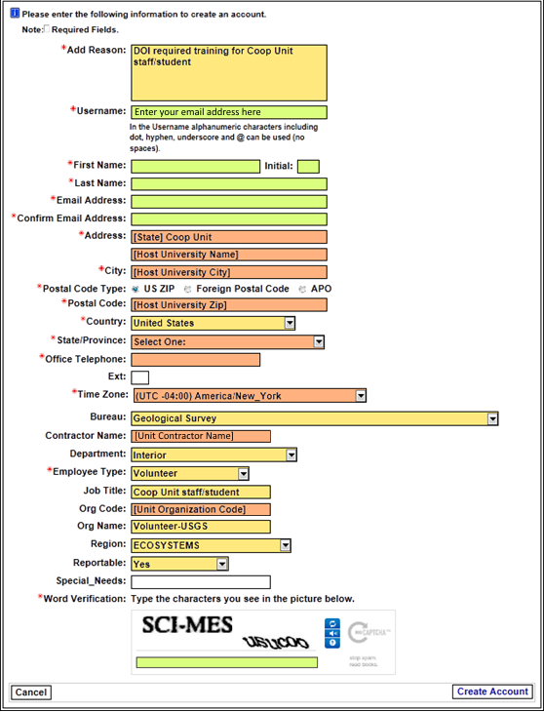

Example completed form for Georgia Coop Unit

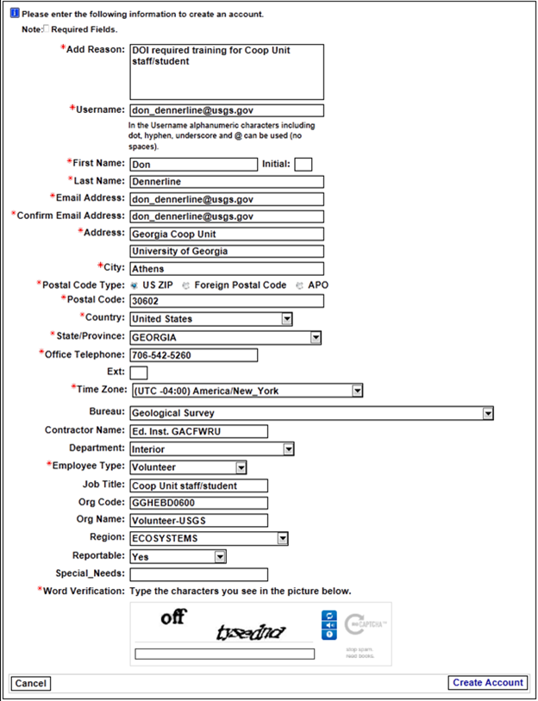
Upon completion, the USGS DOI Learn steward will create the student’s account and revise the student’s username to include “ext” (for external) at the beginning. The student will receive an email from the DOI Learn system saying that they have an account in DOI LEARN and that they can register for courses. If a student gets a message denying them a DOI Learn account, or if they have not received a message after five working days, please let Don Dennerline know as soon as possible (don_dennerline@usgs.gov; 706-705-6042). In the latter case, they might also want to check their “spam” box in case the notification message got caught by their spam filter.

Upon your initial log in, YOU MUST UPDATE YOUR PROFILE by:

- click Settings and Preferences
- click My Profile tab
- update all blank fields
- set the Time Zone
- click Update
- click My Supervisors tab
- add the following people as your supervisors (if they aren’t already there). It is very important that you add the 2 individuals from the CRU headquarters staff (e.g., Don and Shana):
  - Your direct supervisor
  - Don Dennerline
  - Shana Coulby

Contractor Names and Org Codes by Unit
Unit | Contractor Name | Organization Code
Alabama | Ed. Inst. ALCFWRU | GGHEBD0400
Alaska | Ed. Inst. AKCFWRU | GGHEBD3900
Arizona | Ed. Inst. AZCFWRU | GGHEBD3000
Arkansas | Ed. Inst. ARCFWRU | GGHEBD3600
California | Ed. Inst. CACFWRU | GGHEBD3700
Colorado | Ed. Inst. COCFWRU | GGHEBD2800
Florida | Ed. Inst. FLCFWRU | GGHEBD0700
Georgia | Ed. Inst. GACFWRU | GGHEBD0600
Hawaii | Ed. Inst. HICFRU | GGHEBD3800
Idaho | Ed. Inst. IDCFWRU | GGHEBD4300
Iowa | Ed. Inst. IACFWRU | GGHEBD1200
Kansas | Ed. Inst. KSCFWRU | GGHEBD3300
Louisiana | Ed. Inst. LACFWRU | GGHEBD3400
Maine | Ed. Inst. MECFWRU | GGHEBD2300
Maryland | Ed. Inst. MDCFWU | GGHEBD1800
Massachusetts | Ed. Inst. MACFWRU | GGHEBD2200
Minnesota | Ed. Inst. MNCFWRU | GGHEBD1100
Mississippi | Ed. Inst. MSCFWRU | GGHEBD0500
Missouri | Ed. Inst. MOCFWRU | GGHEBD1300
Montana Fish | Ed. Inst. MTCFRU | GGHEBD2600
Montana Wildlife | Ed. Inst. MTCWRU | GGHEBD2500
Nebraska | Ed. Inst. NECFWRU | GGHEBD4400
New Mexico | Ed. Inst. NMCFWRU | GGHEBD3100
New York | Ed. Inst. NYCFWRU | GGHEBD2000
North Carolina | Ed. Inst. NCCFWRU | GGHEBD0900
Oklahoma | Ed. Inst. OKCFWRU | GGHEBD2400
Oregon Fish | Ed. Inst. ORCFRU | GGHEBD4100
Oregon Wildlife | Ed. Inst. ORCWRU | GGHEBD4200
Pennsylvania | Ed. Inst. PACFWRU | GGHEBD1900
South Carolina | Ed. Inst. SCCFWRU | GGHEBD1000
South Dakota | Ed. Inst. SDCFWRU | GGHEBD3200
Tennessee | Ed. Inst. TNCFRU | GGHEBD0800
Texas | Ed. Inst. TXCFWRU | GGHEBD3500
Utah | Ed. Inst. UTCFWRU | GGHEBD2900
Vermont | Ed. Inst. VTCFWRU | GGHEBD2100
Virginia | Ed. Inst. VACFWRU | GGHEBD1700
Washington | Ed. Inst. WACFWRU | GGHEBD4000
West Virginia | Ed. Inst. WVCFWRU | GGHEBD1600
Wisconsin Fish | Ed. Inst. WICFRU | GGHEBD1400
Wisconsin Wildlife | Ed. Inst. WICWRU | GGHEBD1500
Wyoming | Ed. Inst. WYCFWRU | GGHEBD2700

